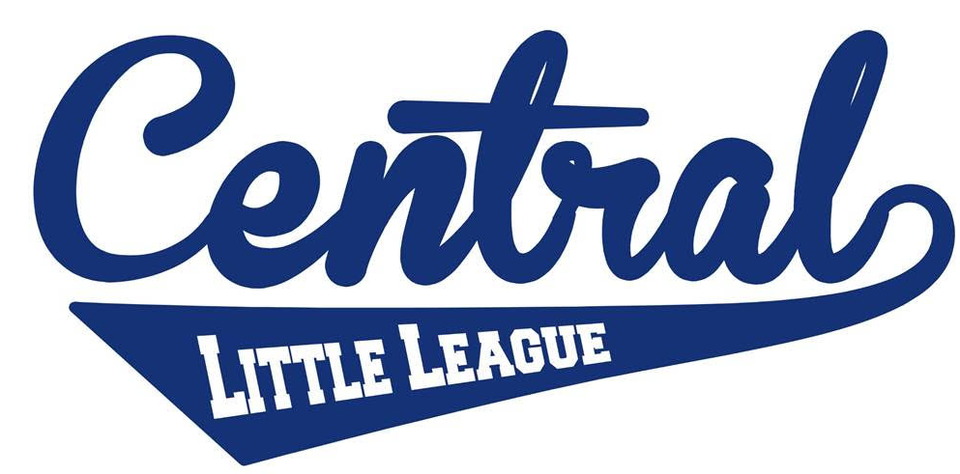

Central Little League
State of Nevada Youth Sports
http://tshq.bluesombrero.com/centrallllv

COVID-19 Preparedness & Safety Plan

General Information

Contact Information

Email: Centrallittleleagueoflasvegas@gmail.com

League President
Michelle Todd
702-960-2811

League Vice President
Keith Jacob
702-806-2369

**All e-mails and phone/text will be answered immediately**

League Name

Central Little League
- Our league boundaries include all of zip codes 89101, 89104, 89110, 89156, 89124, majority of 89115 and 8903o and portions of 89142.
That is the entire area from East Sahara Ave. to the I-15 freeway (on the Northside of Sahara), following the I-15 freeway North and back up toward Apex. This also includes the area between East Vegas Valley and East Sahara Ave. east of Hollywood Boulevard.

Signage
- Signage reminding individuals of established protocols, social distancing of 6
feet, the requirement to wear a face mask and to maintain proper hygiene will be posted at each field location in cooperation with the City of Las Vegas and the State of Nevada.

Capacity and Map

Venue Size

- Games and practices will be held at three locations: Freedom Park located at 850 N Mojave Rd, Las Vegas, NV 89101. Freedom Park is an outdoor venue with 2 ball fields each field is approx. 32,000 square feet. At any given time Central Little League would be using 1-2 of the fields. Mike Morgan Family Park located at 3951 E Bonanza Rd Las Vegas, NV 89110 is an outdoor venue with 2 ball fields each field is approx. 32,000 square feet. Rafael Rivera located at 2850 Stewart Ave. Rafael Rivera is an outdoor venue it has 1 baseball field and is approx. 90.000 square feet. At any given time Central Little League would be using 1-5 of these fields.

Number of Attendees

- One game will be played on each field Monday-Thursday. Each field will have no more than 50 attendees. We have two fields located at Freedom Park. They are far apart and not close together (as shown on the map). By only having 1 game each night on each field it will limit the total of number of attendees at each field. If there is an occasion to hold 2 games in one night on the same field we will schedule 30 minutes between the start and finish time to allow enough time for no overlapping of people.

- Once the maximum number of attendees has been reached a League Official will
declare the venue full and no additional attendees will be allowed.

- A map of each park is attached.

Arrival and Exiting

Times of Games

- There will only be 1 game played on each field therefore there won’t be the need
to space games out by 30 mins. If the need arises due to limit availability of the
Fields the end and start times of the game will allow for a 30 minute gap.

- Players and Coaches will be asked to not arrive more than 15 minutes before
their scheduled game if there is a game before theirs.

- Post-game huddles and team discussions will be limited to brief instructions
about the next game or practice and all individuals will be asked to leave the field
area within 15 minutes of the game ending.

- Any player that arrives more than 15 minutes before their scheduled game will be
asked to wait in the vehicle until which time that the previous teams have left the
field.

Sanitation Schedule Cleaning and Disinfection

Areas to be Cleaned

- Shared equipment, restrooms (will be sanitized before and after, plus every 45 minutes on practice and game days), dugouts, and check-in tables will be sanitized before and after practices/games.

- Central Little League does not operate a concession stand.

Equipment Sanitizing

- The Team Manager will be responsible for separating and disinfecting his or her
own equipment between games.

- Each team will be supplied with a Clorox solution and Clorox wipes to use for disinfecting shared equipment and all surfaces.

- The contact time for this product is 10 mins. With no game immediately after
another there will be ample contact time.

- Parents and coaches will be instructed to wash jerseys and practice clothes
after each game or practice.

- Team Managers and League Officials will ensure that all surfaces are disinfected
and that all trash and debris are picked up.

- Balls used during practice will be rotated every 30 mins and disinfected before the next practice.

- Balls and any other equipment that needs to be sanitized will be removed from the field of play and placed in a designated area.

- During games each team will use their own game ball to avoid cross contamination between teams.

Personal Hygiene

Hygiene

- A flyer will be emailed and posted on Facebook reminding participants to practice good hygiene habits.

Hand Sanitizer

- Each team will be supplied with the appropriate hand sanitizer. Participants will be required to use hand sanitizer before entering the field of play.

- The league will supply any necessary supplies to each team and will provide
additional supplies as needed.

- Hand sanitizer will be located at all dugout locations.

Use of Face Coverings and PPE

- It will be the responsibility of the league to ensure that managers, coaches and staff
are trained in the proper way to wear a mask. It will be the responsibility of the Team
Manager to make sure spectators and players are wearing their masks when needed
and that they are being worn properly. Coaches, managers, sports staff, officials, parents/guardians, and allowed attendees and spectators, Players and athletes will wear masks or cloth face coverings at all times. The exception is if a player is on the field with a bat or glove in their hand.

- League Officials will be responsible for enforcing the mask requirement if needed

Masks are required at all times by everyone in the park (Staff, players, spectators)
except for players actively participating in the game. This means on the field with glove
on or bat in hand.
Players are required to wear masks when they are on the bench/dugout.

- Signage reminding attendees that face masks are required will be displayed at the
entrances and at each field location.

- Staff will be given gloves, masks, and eye protection to be used during sanitization

- The League does have enough PPE to distribute to each team.

Social Distancing

- Reminders will be sent to all participants prior to and during the event to social distance. The league will ensure that the times of games do no overlap and that at least 30 mins is allowed between games to ensure social distancing.

- During baseball games the natural position of the players allows for social distancing.

- Umpires will be distanced 6 feet behind to plate/catcher and will be required to wear a mask.

- Players will be required to wear a mask and maintain 6 feet of distance during any
verbal group instruction.

- Coaches and Managers will be given a designated area down each foul line to use
for times they are not practicing/playing.

- Due to the fact only 1 game will be played on each field each night the number of
spectators will not exceed the maximum.

- There will be no after game high fives or other contact such as handshakes, fist bumps, or hugs. If a player/coach violates this rule there will be a one game suspension. If the player/coach violates this rule for a second time the player/coach will serve a three game suspension and if there is a third violation they will no longer be allowed to participate in the season.

- Players will be reminded that they are not to travel with any persons outside of their
Household.

- Players and spectators will not be sharing any indoor space as all of our events will be
held outdoors. The bleachers are off limits to ensure social distancing.

- Team Managers and League Officials will be responsible for enforcing social distancing.

- Player benches will be marked with 6 foot spacing. If the bench does not allow for the full team
Then additional chairs will be set up outside the dugout area.

Shared Equipment

- Most players have their own equipment. If needed a team may provide a batting helmet that would be disinfected after each use and game. Catchers equipment should only be used by one player. Additional sets of catchers gear can be distributed upon request.

- Parents will be asked to disinfect their players equipment between games.

- Players equipment bags will be spaced 6 feet apart in order to maintain social
distancing.

- The League will ban any food from being on the field of play as well as requiring each
player to bring their own water bottle clearly marked with their name. There will also not
be any team snacks allowed.

- Spitting of any kind is banned along with the eating of seeds, gum, and all similar products will be banned for all players and visitors. We will provide a Sign at each field. Team managers will also communicate this to the players and team.

Health Screenings, Isolation and Testing

- The League will require each adult coach and manager to have a COVID-19
test and email the results to the league.

- Central Little League rents the fields from the City of Las Vegas. Verification of the
test results will be provided to the COLV if requested.

- Each Team will designate a specific person to take each player, manager and coaches
temperature before they enter the field of play.

- Each Team will designate a specific person to collect the health survey screenings.

- Any individual that does not pass the screening requirements will be asked to leave the event. A staff member will help them exit safely without interacting with other people.

- Any individual that has COVID like symptoms while on site will be asked to leave the
Event. A staff member will help them exit safely without interacting with other people. That individual will be encouraged to contact their medical professional.

Employee/Staff Training & Enforcement

- A training meeting will be held to train staff on cleaning, sanitizing and disinfecting

- No corrosive or flammable chemicals will be used

- A training meeting will be held to train staff on face coverings and PPE

- Each game will have at least 2 managers and 1 league official at each game

- Any player, attendee, coach. Manager or staff member that does not comply will be
asked to leave the event and not return until they have agreed to comply going
forward.

